Part – B
- create database lms;
- use lms;
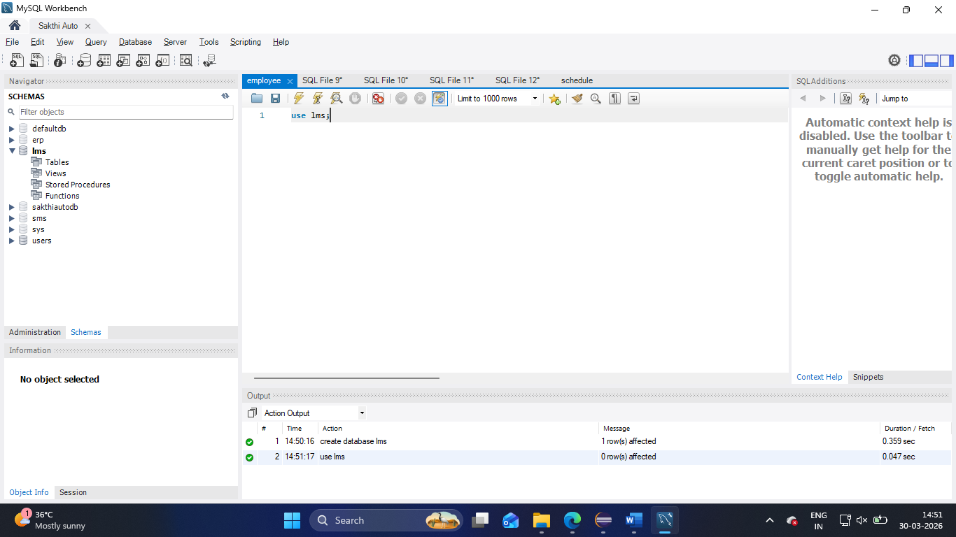

Creating Queries

- CREATE TABLE members (
member_id INT PRIMARY KEY AUTO_INCREMENT,
first_name VARCHAR(100) NOT NULL,
last_name VARCHAR(100) NOT NULL,
dob DATE,
email VARCHAR(255) NOT NULL UNIQUE,
phone VARCHAR(20),
street VARCHAR(255),
city VARCHAR(100),
state VARCHAR(50) DEFAULT 'Tamil Nadu',
zipcode VARCHAR(10),
membership_type VARCHAR(20) NOT NULL,

CHECK (membership_type IN ('BASIC', 'PREMIUM', 'VIP'))
);

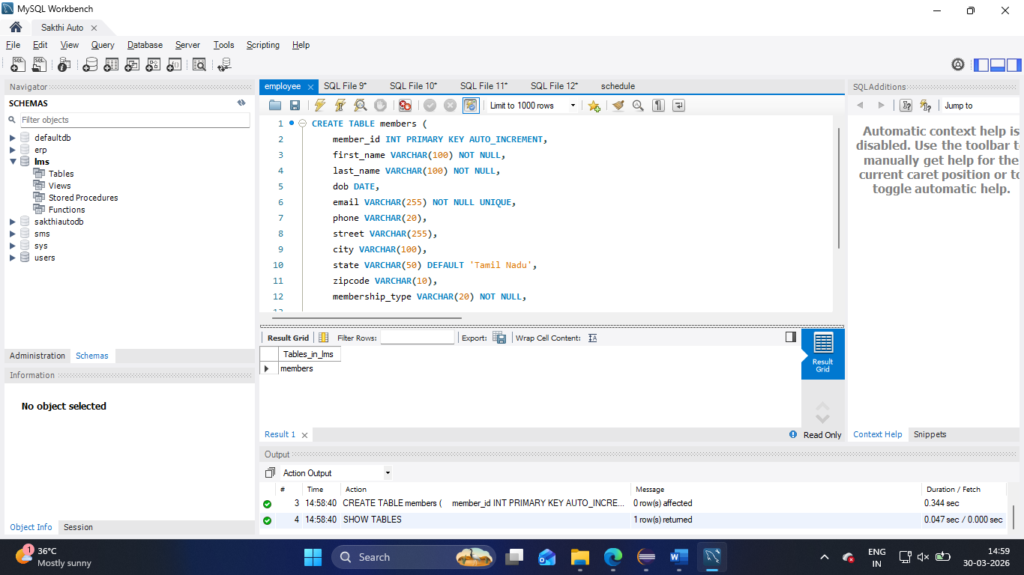

- CREATE TABLE categories (
category_id INT PRIMARY KEY AUTO_INCREMENT,
category_name VARCHAR(150) NOT NULL UNIQUE,
description VARCHAR(500)
);
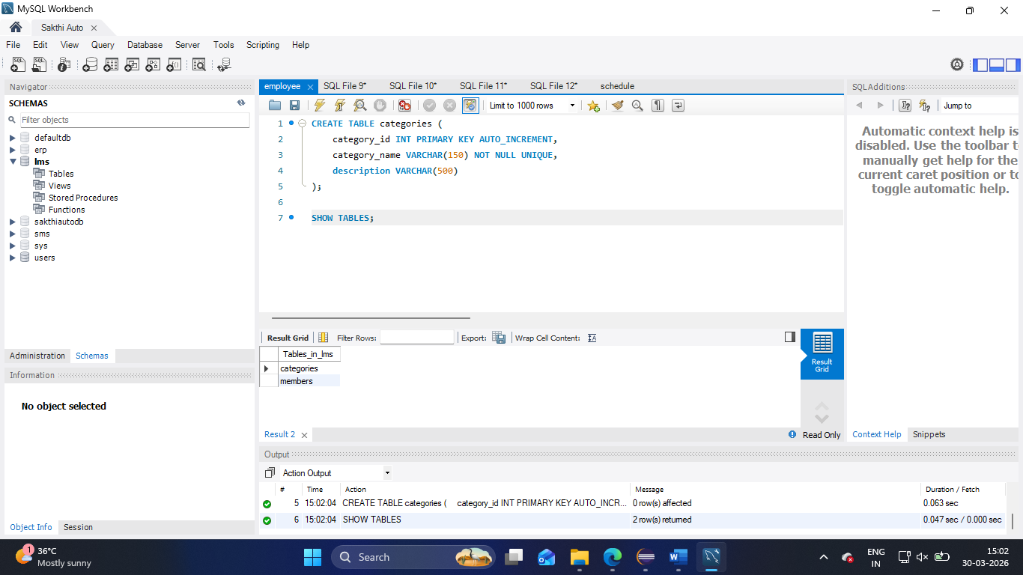
- CREATE TABLE books (
book_id INT PRIMARY KEY AUTO_INCREMENT,
title VARCHAR(255) NOT NULL,
author VARCHAR(200) NOT NULL,
isbn VARCHAR(20) NOT NULL UNIQUE,
publisher VARCHAR(200),
pub_year INT,
price DECIMAL(5,2) NOT NULL,
total_copies INT NOT NULL DEFAULT 1,
category_id INT NOT NULL,

FOREIGN KEY (category_id) REFERENCES categories(category_id)
);
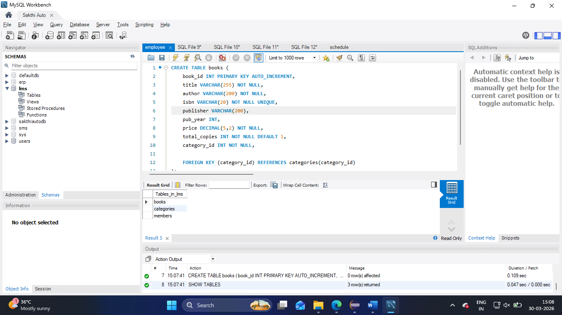

- CREATE TABLE borrows (
borrow_id INT PRIMARY KEY AUTO_INCREMENT,
member_id INT NOT NULL,
book_id INT NOT NULL,
borrow_date DATE NOT NULL,
due_date DATE NOT NULL,
return_date DATE,
status VARCHAR(20) NOT NULL,

FOREIGN KEY (member_id) REFERENCES members(member_id),
FOREIGN KEY (book_id) REFERENCES books(book_id),
CHECK (status IN (' Borrowed','Returned','Overdue'))
);

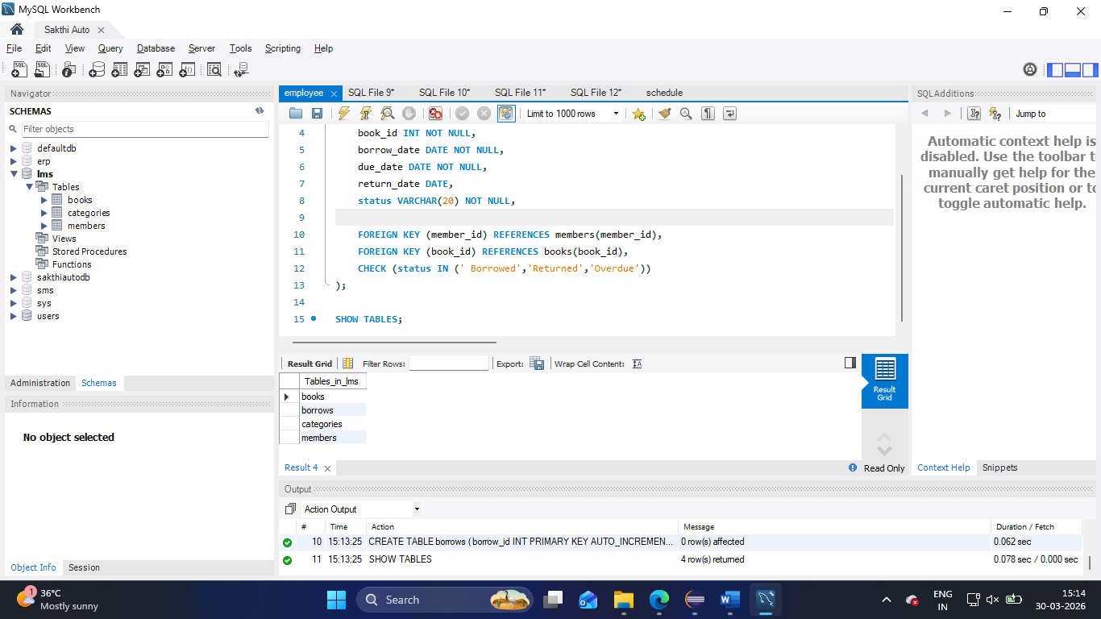

- CREATE TABLE fines (
fine_id INT PRIMARY KEY AUTO_INCREMENT,
borrow_id INT NOT NULL,
member_id INT NOT NULL,
fine_amount DECIMAL(5, 2) NOT NULL,
paid_amount DECIMAL(5, 2) DEFAULT 0,
fine_date DATE NOT NULL,
payment_status VARCHAR(20) NOT NULL,

FOREIGN KEY (member_id) REFERENCES members(member_id),
FOREIGN KEY (borrow_id) REFERENCES borrows(borrow_id),
CHECK (payment_status IN ('Paid','Unpaind','Waived'))
);

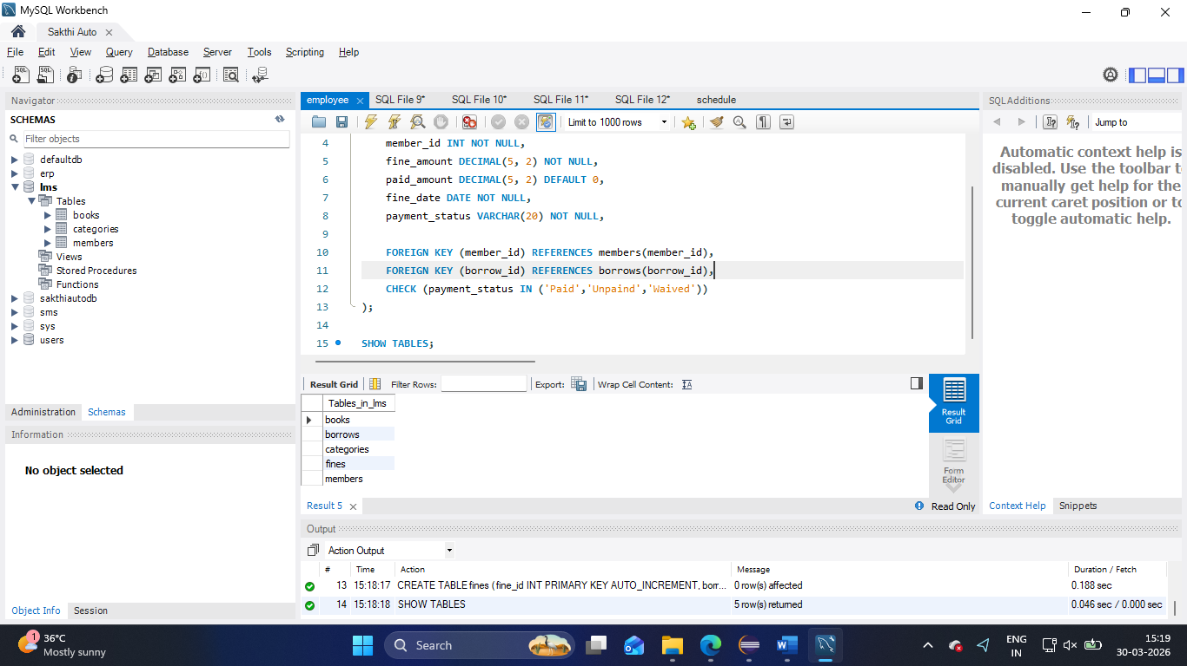

Insert Queries
- INSERT INTO members
(first_name, last_name, dob, email, phone, street, city, state, zipcode, membership_type)
VALUES
('Vigneshwaran', 'M', '2005-04-12', 'vignesh1@gmail.com', '9092174486', 'ABC Street', 'Salem', 'Tamil Nadu', '637501', 'BASIC'),
('Vetri', 'B', '2005-04-13', 'vetri@gmail.com', '9092174487', 'ABC Street', 'Salem', 'Tamil Nadu', '637501', 'PREMIUM'),
('Prasanna', 'K', '2005-04-14', 'prasanna@gmail.com', '9092174488', 'ABC Street', 'Salem', 'Tamil Nadu', '637501', 'VIP');

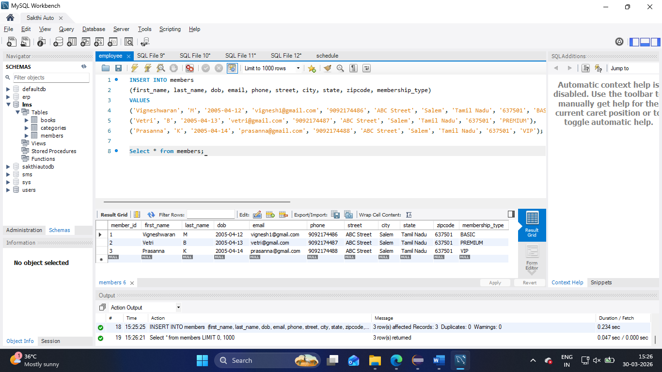

- INSERT INTO categories
(category_name, description)
VALUES ('CRIME', 'This is a crime category'),
('Fiction', 'This is a fiction category'),
('Thriller', 'This is a thriller category');

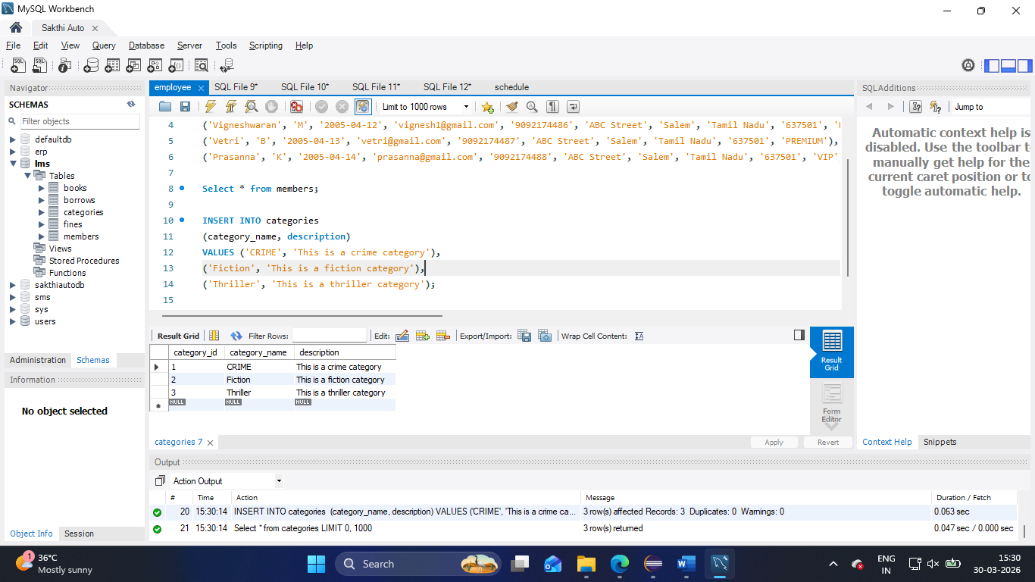

- INSERT INTO books
(title, author, isbn, publisher, pub_year, price, total_copies, category_id)
VALUES
('Fight Club', 'Fincher', '12345', 'Apple', 1996, 499.00, 10, 1),
('Interstellar', 'Nolan', '12346', 'ABC', 2014, 599.00, 5, 2),
('The Conjuring', 'Nolan', '123473', 'ABC', 2013, 399.00, 7, 3);

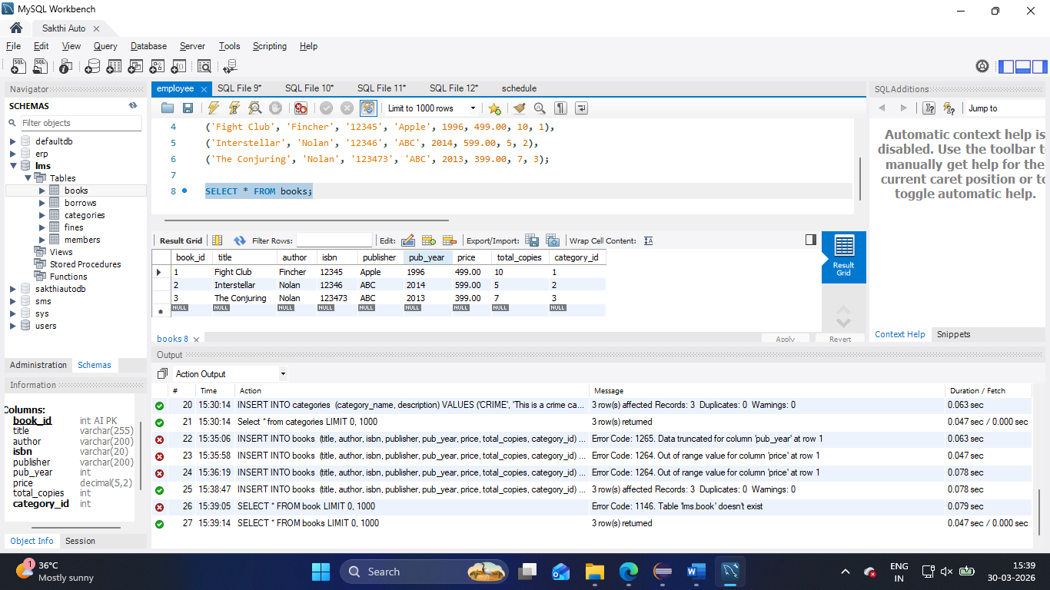

- INSERT INTO borrows
(member_id, book_id, borrow_date, due_date, return_date, status)
VALUES
(1, 1, '2026-03-28', '2026-03-31', '2026-03-30', 'Returned'),
(2, 2, '2026-03-28', '2026-03-31', '2026-03-30', 'Returned'),
(3, 3, '2026-03-28', '2026-03-31', '2026-03-30', 'Returned');

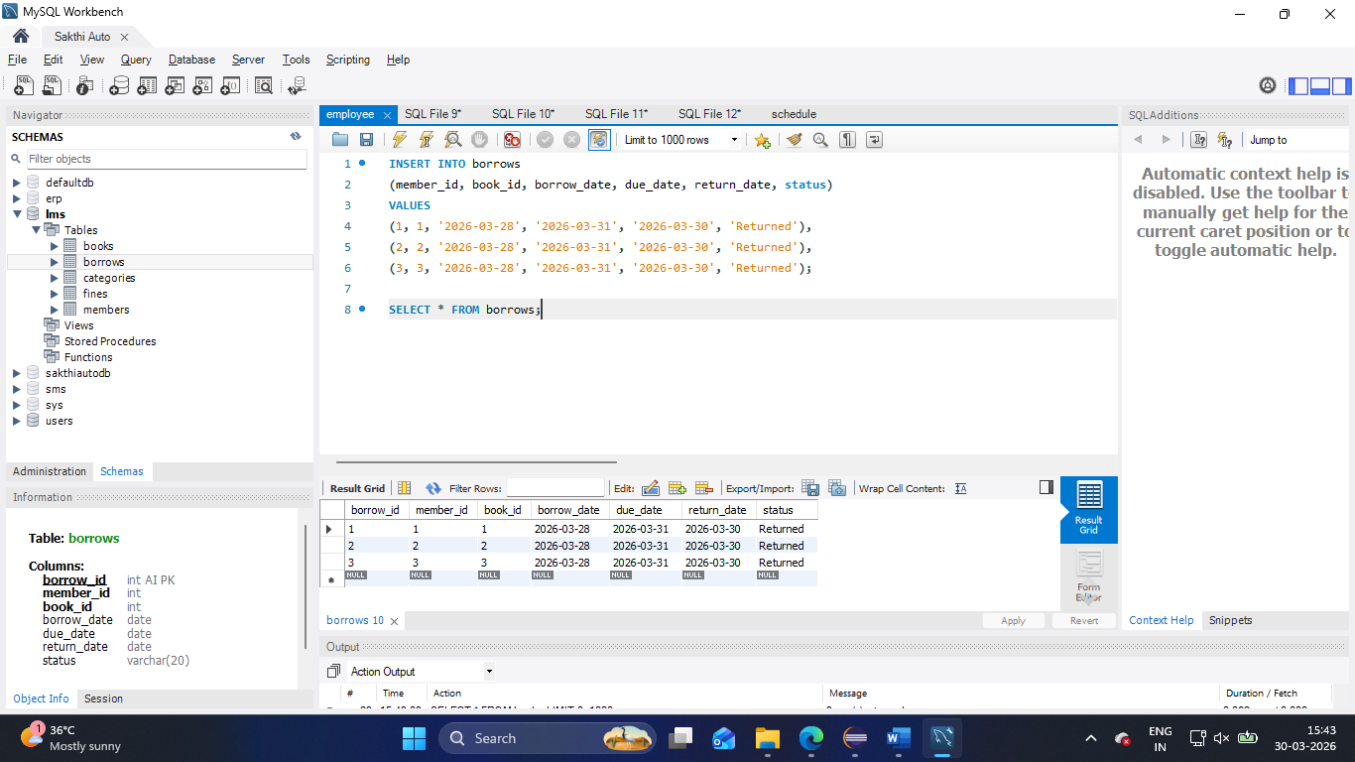

- INSERT INTO fines
(borrow_id ,member_id, fine_amount, paid_amount, fine_date, payment_status)
VALUES
(1, 1, 100, 100, '2026-03-28', 'Paid'),
(2, 2, 100, 100, '2026-03-28', 'Paid'),
(3, 3, 100, 100, '2026-03-28', 'Paid');

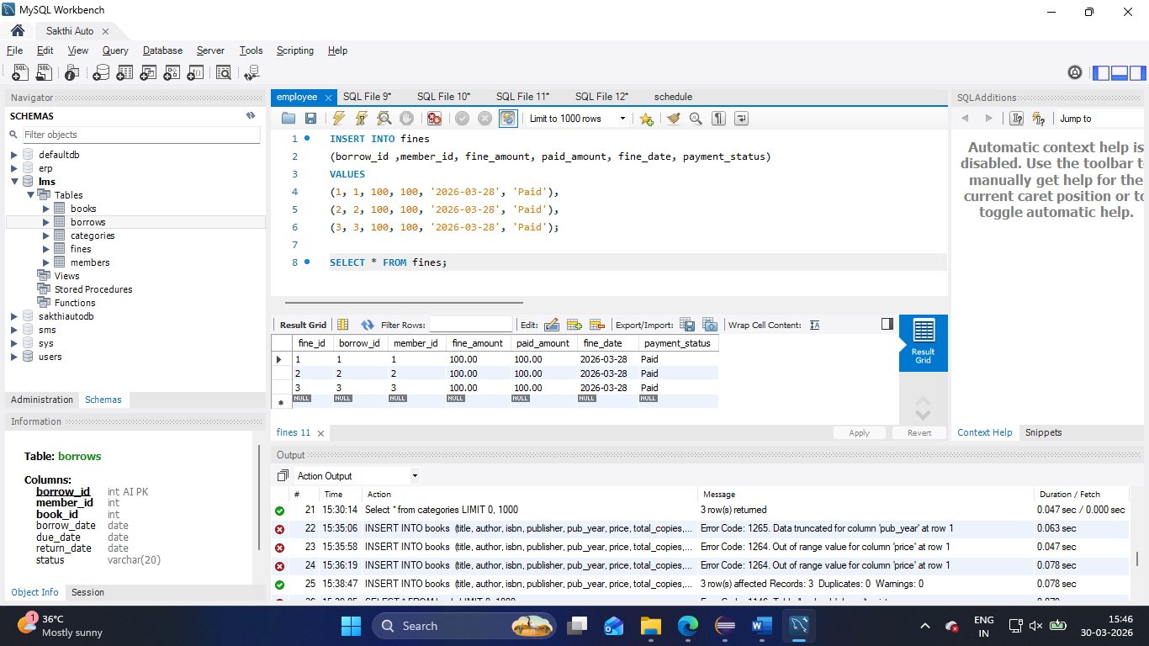

2.
1. create database HR;
use HR;
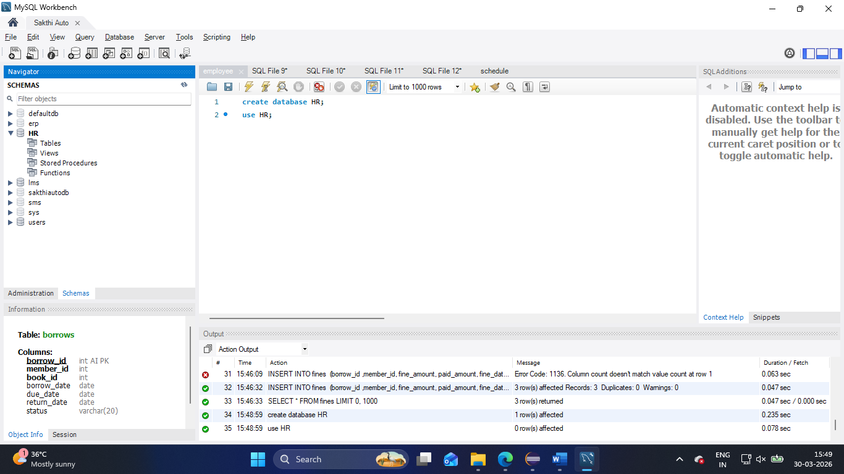

2. CREATE TABLE employee (
member_id INT PRIMARY KEY AUTO_INCREMENT,
first_name VARCHAR(100) NOT NULL,
last_name VARCHAR(100) NOT NULL,
dob DATE,
email VARCHAR(255) NOT NULL UNIQUE,
phone VARCHAR(20),
street VARCHAR(255),
city VARCHAR(100),
state VARCHAR(50) DEFAULT 'Tamil Nadu',
country_id INT,
zipcode VARCHAR(10),
salary DECIMAL(10, 2),
experience INT,
commision_percentage INT,
department VARCHAR(10)
);
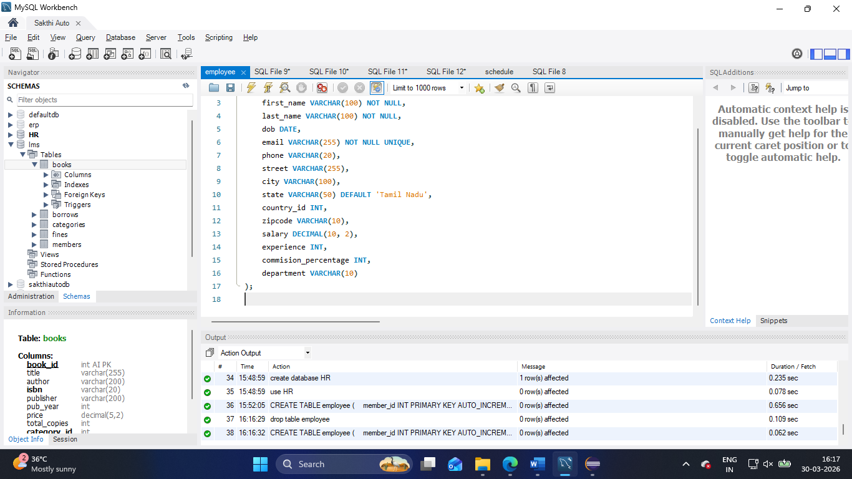
3. INSERT INTO employee (
first_name,last_name,dob,email,phone,street,city,state, country_id,zipcode,salary,experience, department, commision_percentage
)
VALUES ('Vigneshwaran', 'M', '2005-04-12', 'vignesh1@gmail.com', '9092174486', 'ABC Street', 'Salem', 'Tamil Nadu', 1, '637501', 10000, 5, 'CSE', 10),
('Vetri', 'B', '2005-04-13', 'vetri@gmail.com', '9092174487', 'ABC Street', 'Salem', 'Tamil Nadu', 1, '637501', 100000, 28, 'CSE', null),
('Prasanna', 'K', '2005-04-14', 'prasanna@gmail.com', '9092174488', 'ABC Street', 'Salem', 'Tamil Nadu', 1, '637501',500000, 28, 'CSE', null);
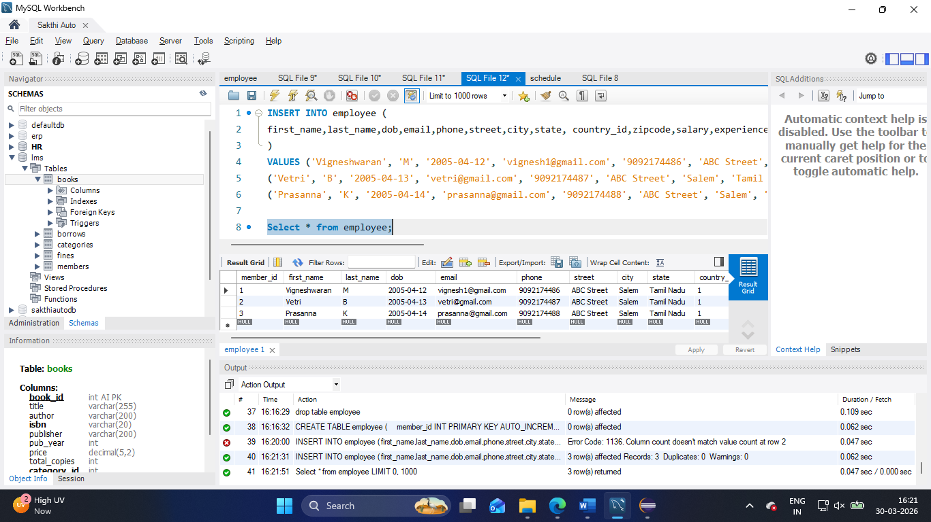

Answers:
- Select country_id, count(*) from employee group by country_id;
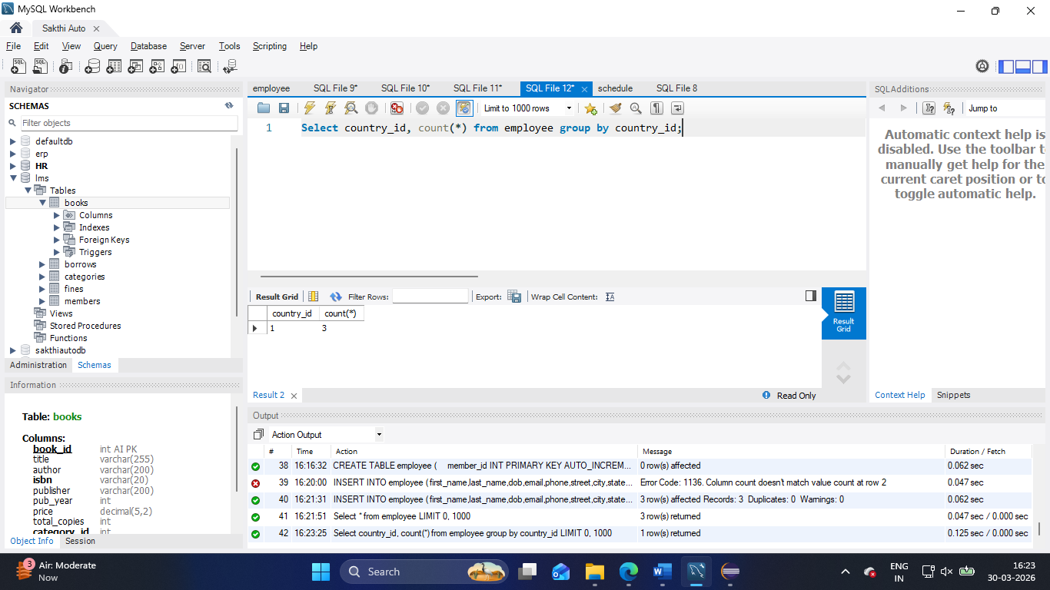

- Update employee set salary = salary + salary*0.25;
Select * from employee where salary > 10000;
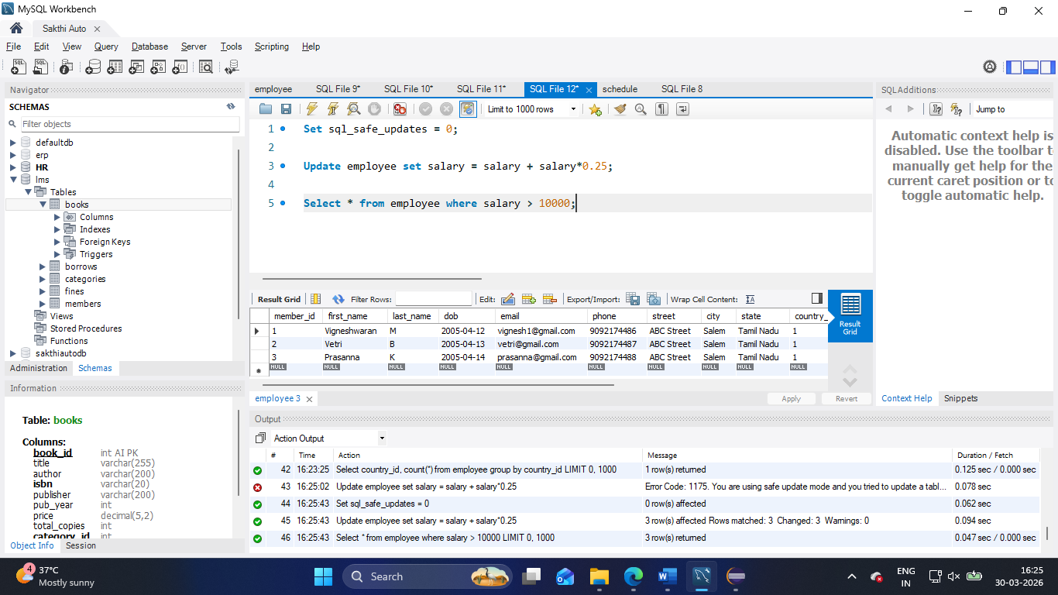

- select first_name, last_name, experience from employee where experience > 27;
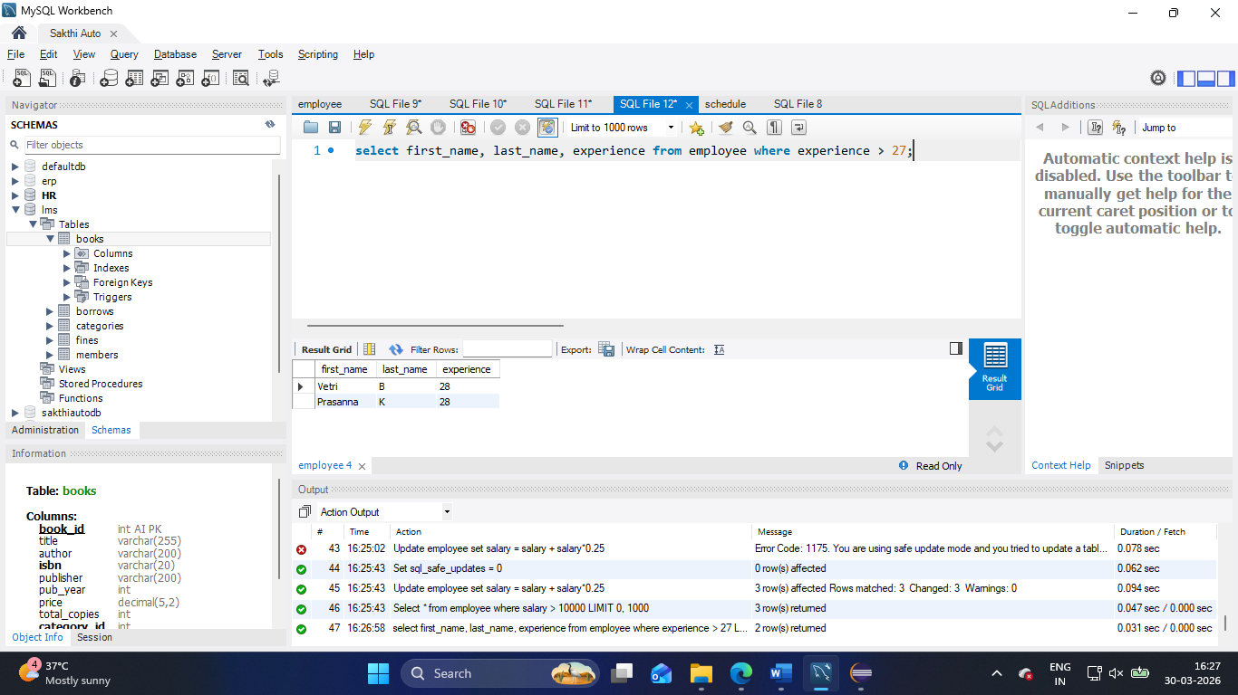

- select * from employee where commision_percentage is null and salary between 5000 and 10000 and department not in (50, 80);
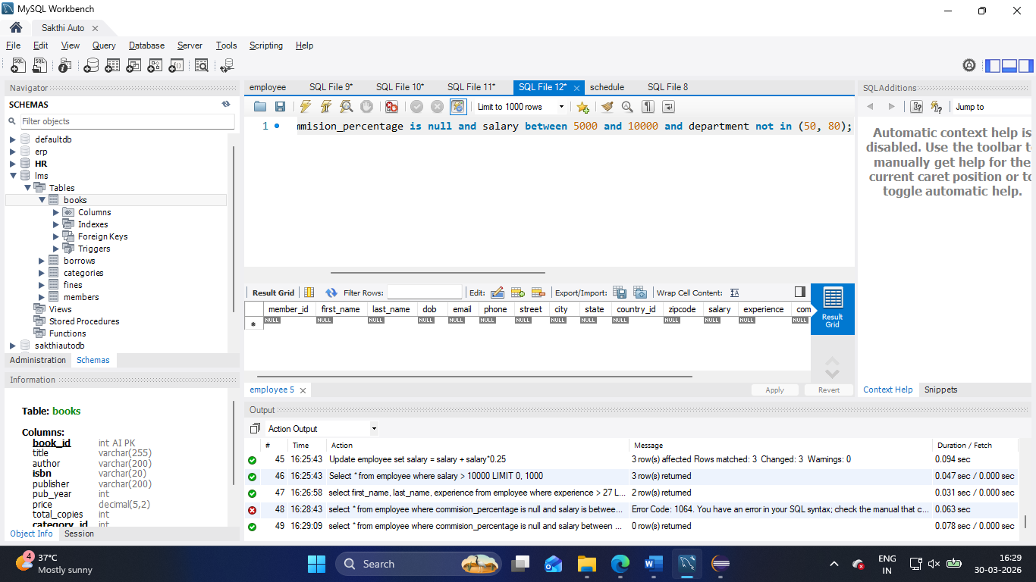

- select job_id, avg(salary) as AVG_Salary from employee group by job_id having AVG_Salary > 10000;
